How to Install Python for Engineers (Using the Anaconda Platform)

**\*\*\*If you already have a working Python (Version 3+) and have a functioning PIP you don’t need to necessarily follow this tutorial\*\*\***

# Google Search Anaconda

Go to the browser and search for ‘Anaconda’. The link you should be looking for is [www.anaconda.com](http://www.anaconda.com) . Click on the link.



# Click on the Download button on the TOP RIGHT



# Click Download button below Anaconda Distribution

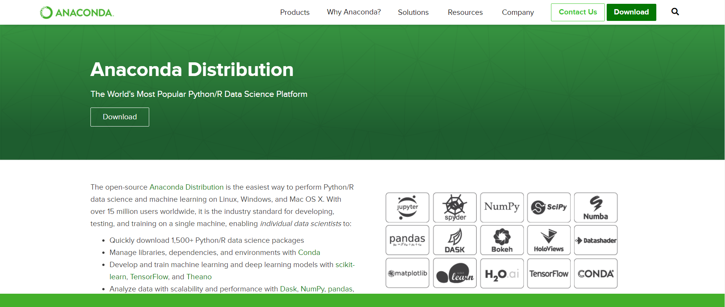

# Downloading the Installer

Choose your operating system from the top (Windows macOS or Linux)

For **windows** Download Python 3.7 (or any Python 3 Version)

Make sure to properly select 64bit or 32 bit based on your operating system.

To find that press (Windows Key + Pause Break Button) to open device specs to check.

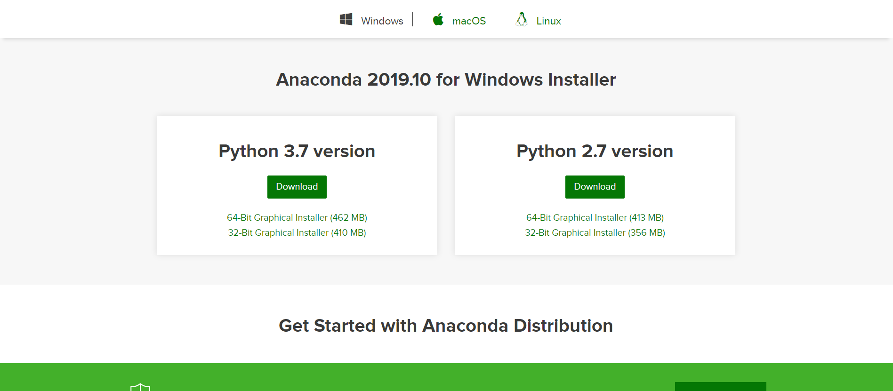

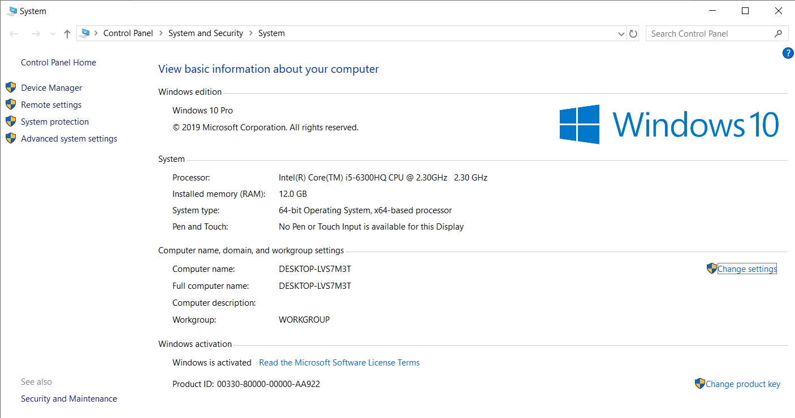

# Once Downloaded Open Installer EXE file

Click Next After Opening

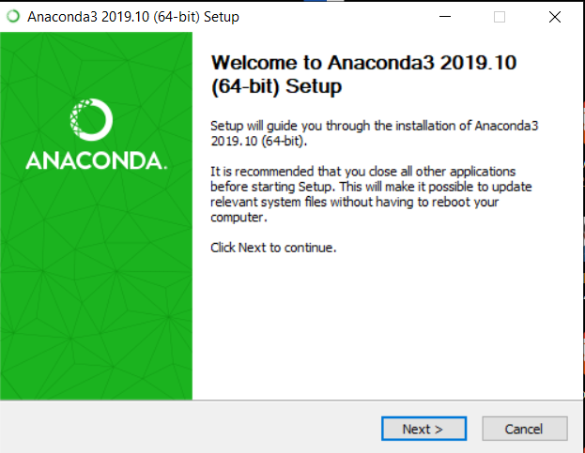

Agree to the Terms and Conditions

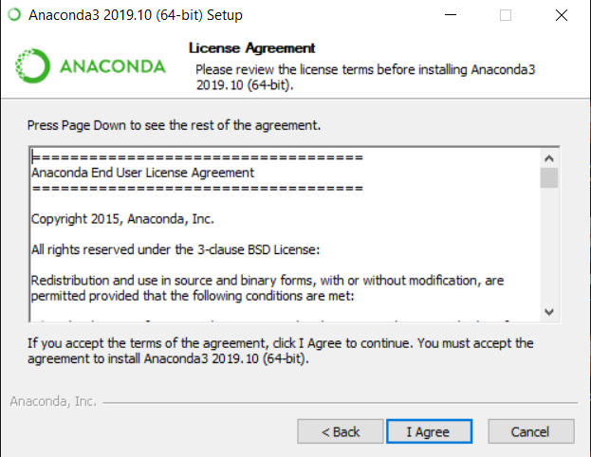

Click Next to Continue

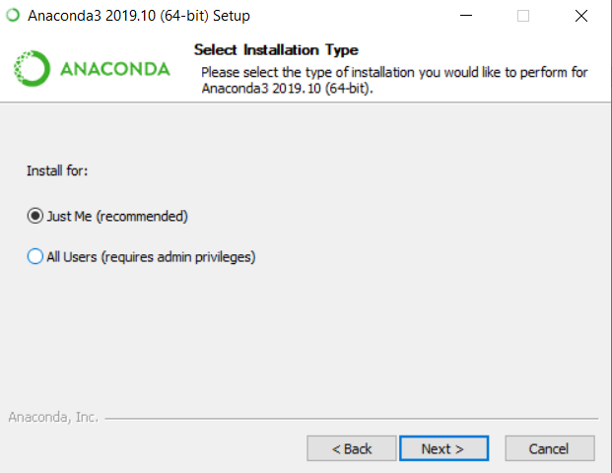

Install Anaconda anywhere on your C:\ Drive with no spaces in the name. For example “C:\My Anaconda” is a bad name as it may cause errors due to spaces. You can use a name like “C:\Anaconda3” or “C:\Anaconda”.

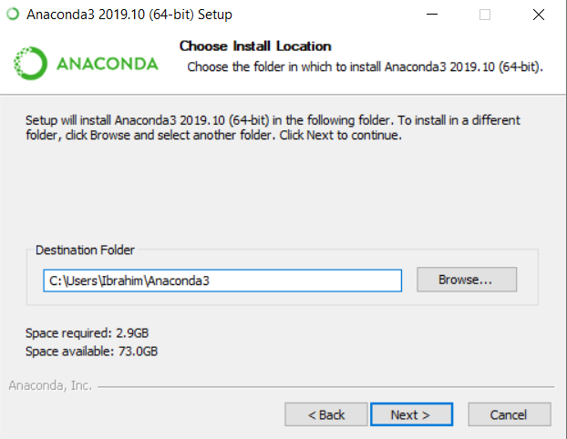

Click “Register Anaconda as my default Python 3.X”

Do not add Anaconda to PATH

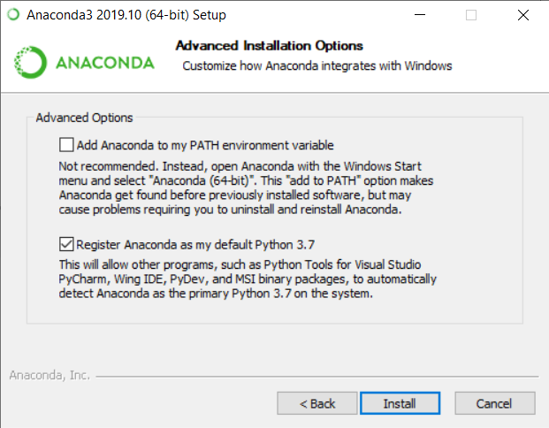

Click Install and It should complete without errors.

# Checking whether installation is successful

Search for and open Anaconda Prompt(Anaconda)

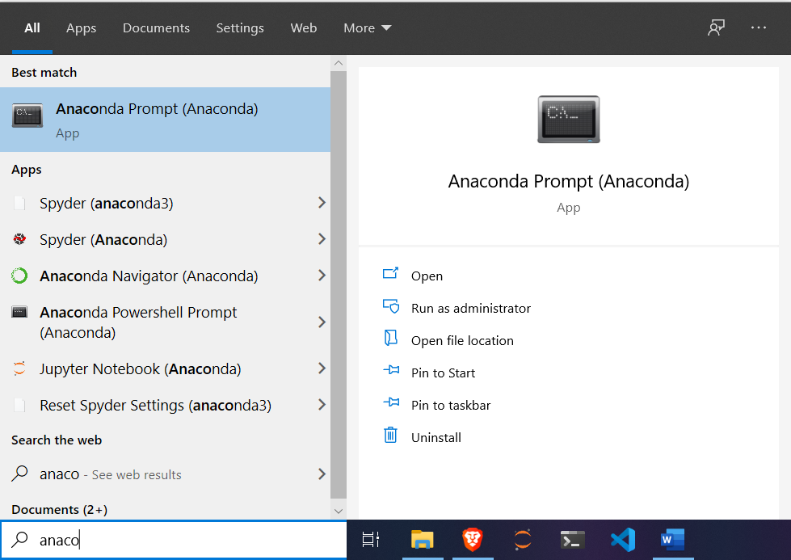

Type *python* in the prompt and it should open Python Console.

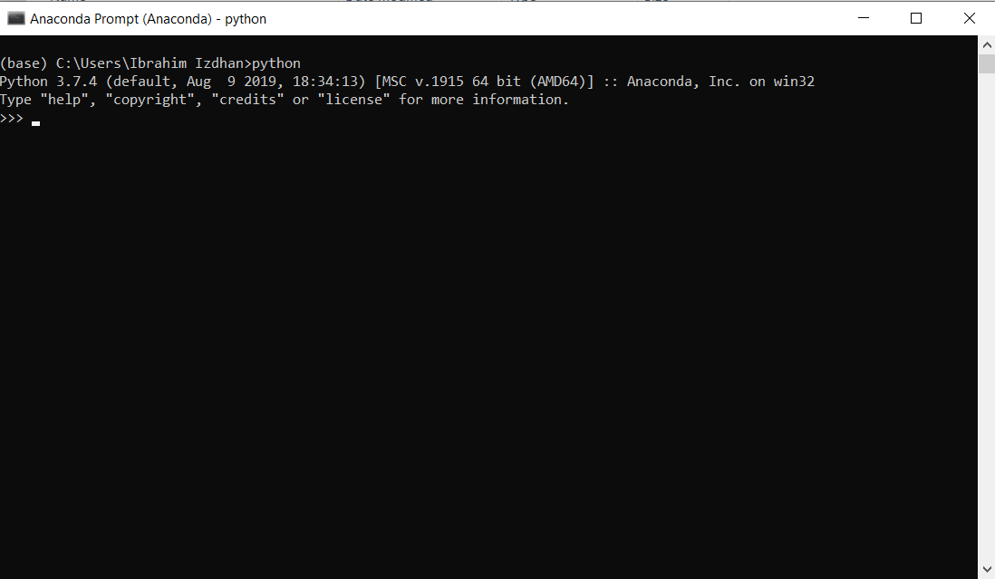

Contact the following UCSI IET Members if you have any issue:

**Ibrahim Izdhan**

01161843966 (WhatsApp)

**Ng Tsu Yao**

010394 6101 (WhatsApp)